**Predicting best place to start a restaurant**

**Abhishek Bhattacharya**

**1. Introduction**

I want to open a restaurant in Toronto so I need the data of the areas where there are many restaurants. As if I want to open my first restaurant I want it to be in an area where there are lot of restaurants which would be likely a hub or a recreational place. So after analyzing all the areas in Toronto I want to come up with the area where there is many restaurant and has recreational hubs, parks, movie halls etc. So that I can look for a place to start my restaurant.

**1.1 Interest**

To open a restaurant I need to get the data where the restaurant business is working well. So I need to analyse places in Toronto where I can start my business to maximize my profit.

**2. Data Acquisition**

For simplicity purpose I am taking only the places close to Toronto. From the wiki page of Toronto I am web scraping the data and making the data available, I am making the data structures so that to make it simple to understand and analyse.

**2.2 Data Cleaning**

When I am extracting data from the webpage I am getting all the data in an unstructured way and getting data of all the cities in Toronto so I need to filter out only the necessary data for better understanding.

2.3 Data Moulding

Data needs to be moulded with there geostationary locations and then appended with the data that has been processed.

**3. Maps**

All the different major areas in Toronto.

Map is below

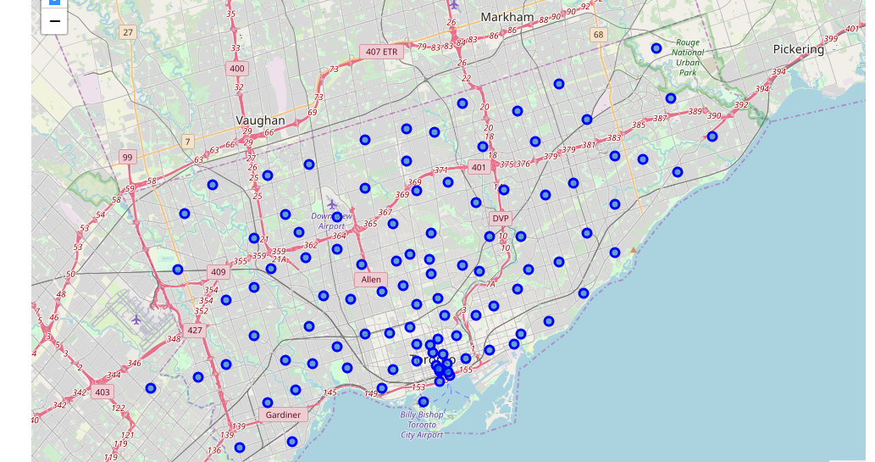

**Places with their most common places**

----Adelaide, King, Richmond----

venue freq

0 Coffee Shop 0.08

1 Café 0.05

2 Steakhouse 0.04

3 Bar 0.04

4 Cosmetics Shop 0.03

----Berczy Park----

venue freq

0 Coffee Shop 0.09

1 Cocktail Bar 0.05

2 Farmers Market 0.04

3 Bakery 0.04

4 Seafood Restaurant 0.04

----Brockton, Exhibition Place, Parkdale Village----

venue freq

0 Yoga Studio 0.09

1 Coffee Shop 0.09

2 Café 0.09

3 Breakfast Spot 0.09

4 Convenience Store 0.04

----Business Reply Mail Processing Centre 969 Eastern----

venue freq

0 Light Rail Station 0.12

1 Yoga Studio 0.06

2 Auto Workshop 0.06

3 Gym / Fitness Center 0.06

4 Garden Center 0.06

----CN Tower, Bathurst Quay, Island airport, Harbourfront West, King and Spadina, Railway Lands, South Niagara----

venue freq

0 Airport Service 0.18

1 Airport Lounge 0.12

2 Airport Terminal 0.12

3 Boutique 0.06

4 Plane 0.06

----Cabbagetown, St. James Town----

venue freq

0 Coffee Shop 0.07

1 Café 0.07

2 Bakery 0.05

3 Pizza Place 0.05

4 Italian Restaurant 0.05

----Central Bay Street----

venue freq

0 Coffee Shop 0.14

1 Café 0.06

2 Italian Restaurant 0.05

3 Ice Cream Shop 0.05

4 Burger Joint 0.04

----Chinatown, Grange Park, Kensington Market----

venue freq

0 Café 0.08

1 Vegetarian / Vegan Restaurant 0.06

2 Bar 0.05

3 Mexican Restaurant 0.04

4 Vietnamese Restaurant 0.04

----Christie----

venue freq

0 Grocery Store 0.19

1 Café 0.19

2 Park 0.12

3 Nightclub 0.06

4 Baby Store 0.06

----Church and Wellesley----

venue freq

0 Coffee Shop 0.07

1 Japanese Restaurant 0.06

2 Sushi Restaurant 0.05

3 Gay Bar 0.03

4 Restaurant 0.03

----Commerce Court, Victoria Hotel----

venue freq

0 Coffee Shop 0.11

1 Café 0.06

2 Hotel 0.06

3 Restaurant 0.05

4 Deli / Bodega 0.03

----Davisville----

venue freq

0 Dessert Shop 0.09

1 Sandwich Place 0.09

2 Pharmacy 0.06

3 Coffee Shop 0.06

4 Sushi Restaurant 0.06

----Davisville North----

venue freq

0 Park 0.14

1 Hotel 0.14

2 Breakfast Spot 0.14

3 Food & Drink Shop 0.14

4 Gym 0.14

----Deer Park, Forest Hill SE, Rathnelly, South Hill, Summerhill West----

venue freq

0 Pub 0.13

1 Coffee Shop 0.13

2 Sports Bar 0.07

3 Bagel Shop 0.07

4 Supermarket 0.07

----Design Exchange, Toronto Dominion Centre----

venue freq

0 Coffee Shop 0.12

1 Café 0.08

2 Hotel 0.06

3 Restaurant 0.05

4 American Restaurant 0.03

----Dovercourt Village, Dufferin----

venue freq

0 Bakery 0.13

1 Pharmacy 0.13

2 Supermarket 0.13

3 Park 0.07

4 Bank 0.07

----First Canadian Place, Underground city----

venue freq

0 Coffee Shop 0.10

1 Café 0.08

2 Hotel 0.05

3 Restaurant 0.04

4 Burger Joint 0.03

----Forest Hill North, Forest Hill West----

venue freq

0 Park 0.2

1 Trail 0.2

2 Sushi Restaurant 0.2

3 Bus Line 0.2

4 Jewelry Store 0.2

----Harbord, University of Toronto----

venue freq

0 Café 0.14

1 Bookstore 0.06

2 Bar 0.06

3 Restaurant 0.06

4 Japanese Restaurant 0.06

----Harbourfront East, Toronto Islands, Union Station----

venue freq

0 Coffee Shop 0.13

1 Aquarium 0.05

2 Hotel 0.05

3 Café 0.04

4 Brewery 0.03

----Harbourfront, Regent Park----

venue freq

0 Coffee Shop 0.17

1 Park 0.06

2 Café 0.06

3 Bakery 0.06

4 Pub 0.06

----High Park, The Junction South----

venue freq

0 Mexican Restaurant 0.09

1 Café 0.09

2 Fried Chicken Joint 0.04

3 Arts & Crafts Store 0.04

4 Fast Food Restaurant 0.04

----Lawrence Park----

venue freq

0 Park 0.33

1 Swim School 0.33

2 Bus Line 0.33

3 Yoga Studio 0.00

4 Music Venue 0.00

----Little Portugal, Trinity----

venue freq

0 Bar 0.12

1 Coffee Shop 0.06

2 Asian Restaurant 0.05

3 Men's Store 0.03

4 Restaurant 0.03

----Moore Park, Summerhill East----

venue freq

0 Restaurant 1.0

1 Yoga Studio 0.0

2 Nightclub 0.0

3 Men's Store 0.0

4 Mexican Restaurant 0.0

----North Toronto West----

venue freq

0 Sporting Goods Shop 0.12

1 Clothing Store 0.08

2 Coffee Shop 0.08

3 Yoga Studio 0.04

4 Spa 0.04

----Parkdale, Roncesvalles----

venue freq

0 Breakfast Spot 0.13

1 Gift Shop 0.13

2 Bookstore 0.07

3 Italian Restaurant 0.07

4 Eastern European Restaurant 0.07

----Rosedale----

venue freq

0 Park 0.4

1 Playground 0.2

2 Trail 0.2

3 Building 0.2

4 Music Venue 0.0

----Roselawn----

venue freq

0 Garden 1.0

1 Yoga Studio 0.0

2 Market 0.0

3 Mediterranean Restaurant 0.0

4 Men's Store 0.0

----Runnymede, Swansea----

venue freq

0 Café 0.09

1 Sushi Restaurant 0.06

2 Pizza Place 0.06

3 Coffee Shop 0.06

4 Italian Restaurant 0.06

----Ryerson, Garden District----

venue freq

0 Coffee Shop 0.09

1 Clothing Store 0.07

2 Middle Eastern Restaurant 0.03

3 Café 0.03

4 Cosmetics Shop 0.03

----St. James Town----

venue freq

0 Coffee Shop 0.07

1 Restaurant 0.06

2 Café 0.05

3 Hotel 0.05

4 Italian Restaurant 0.04

----Stn A PO Boxes 25 The Esplanade----

venue freq

0 Coffee Shop 0.11

1 Café 0.04

2 Seafood Restaurant 0.04

3 Restaurant 0.04

4 Cocktail Bar 0.03

----Studio District----

venue freq

0 Café 0.10

1 Coffee Shop 0.08

2 Italian Restaurant 0.05

3 Bakery 0.05

4 American Restaurant 0.05

----The Annex, North Midtown, Yorkville----

venue freq

0 Café 0.12

1 Sandwich Place 0.12

2 Coffee Shop 0.12

3 Pizza Place 0.08

4 Cosmetics Shop 0.04

----The Beaches----

venue freq

0 Health Food Store 0.17

1 Trail 0.17

2 Coffee Shop 0.17

3 Other Great Outdoors 0.17

4 Pub 0.17

----The Beaches West, India Bazaar----

venue freq

0 Sandwich Place 0.10

1 Fish & Chips Shop 0.05

2 Liquor Store 0.05

3 Sushi Restaurant 0.05

4 Steakhouse 0.05

----The Danforth West, Riverdale----

venue freq

0 Greek Restaurant 0.21

1 Coffee Shop 0.09

2 Italian Restaurant 0.07

3 Furniture / Home Store 0.05

4 Ice Cream Shop 0.05

**Conclution**

Chinatown, Grange Park, Kensington Market has many café bar restaurant altogether and has a great people walkins.